**Reliable telephone turn service**

**Service description**

**SECOM Co., Ltd.**

**June 2019**

**Version 1.0**

Revision history

|  |  |  |
| --- | --- | --- |
| Version number | date | Contents |
| V1.0 | 2019/2/19 | First edition |
|  |  |  |
|  |  |  |
|  |  |  |
|  |  |  |
|  |  |  |
|  |  |  |
|  |  |  |
|  |  |  |
|  |  |  |
|  |  |  |
|  |  |  |
|  |  |  |
|  |  |  |
|  |  |  |
|  |  |  |
|  |  |  |
|  |  |  |

**table of contents**

1.あんしん電話当番サービスについて 4

1.1 はじめに 4

1.2 用語の定義 4

2. サービス提供条件 5

2.1 お客様の義務 5

2.2 お客様情報の届出 6

2.3 免責 6

3. サービス内容 6

3.1 コースメニュー 7

3.2 本サービスに関する問い合わせ 7

3.2.1 セコムの問い合わせ窓口 7

3.2.2 TMJの問い合わせ窓口 8

# 1. About reliable telephone duty service

## 1.1 Introduction

“Anshin Telephone Duty Service” (hereinafter referred to as “this Service”) is a service that Secom provides for telephone reception and telephone support on behalf of the customer, such as outside of the customer's business hours or when going out. A part of this service is performed by Secom Trust Systems Co., Ltd. and TMJ Co., Ltd.

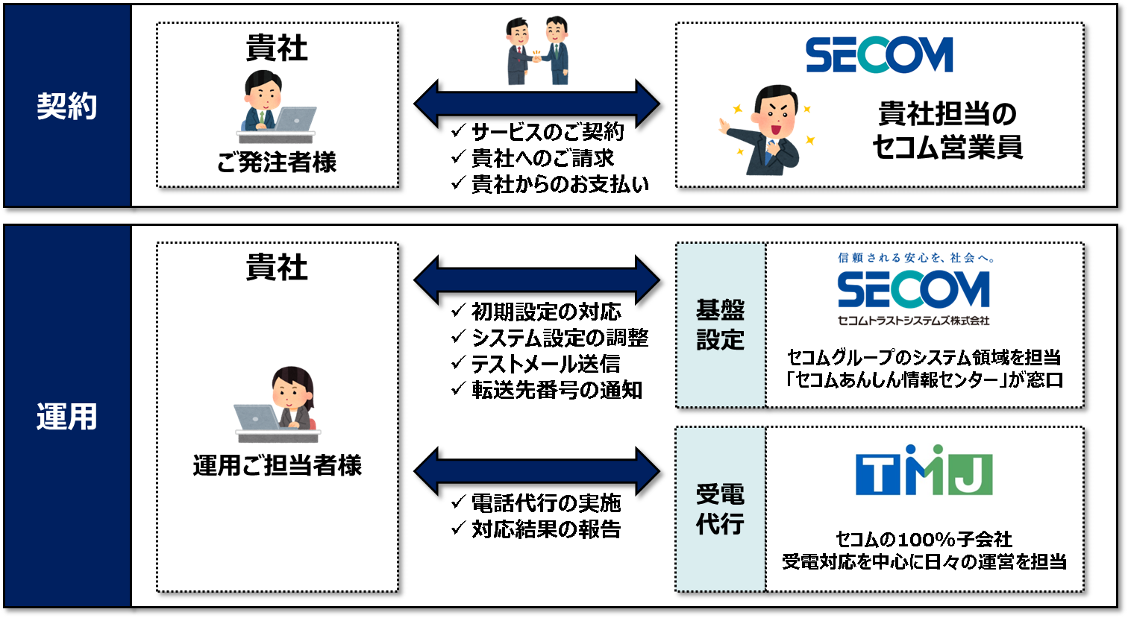

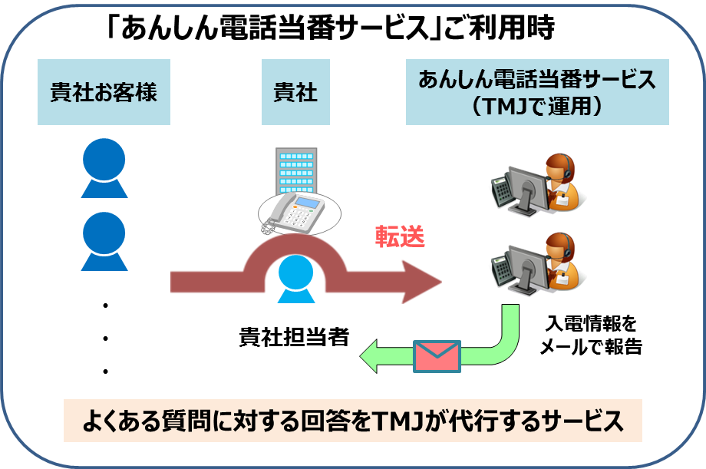

Service provision system

## 1.2 Definition of terms

(1) Reliable telephone duty center

Call center that accepts telephone calls from users and handles calls.

(2) Reliable telephone duty service setting request form

This service settings document defines the administrator, contact information for the administrator, the person in charge, the email address for the report, and frequently asked questions and answers (hereinafter referred to as the “questionnaire”). (Hereafter referred to as “Setting Request Form”)

* Up to 4 email addresses can be reported.

* Up to 5 questionnaires.

(3) Telephone transfer service

A service provided by a carrier that forwards incoming calls to your phone number to a preset phone number.

In addition, transfer settings should be set to the forwarding number dedicated to customers prepared by SECOM.

(4) Administrator

In this service, the administrator of the customer who will be the point of contact with SECOM for setting changes. Up to two administrators can be registered.

(5) Person in charge

In this service, the person in charge of the customer who receives reports from users by email from SECOM. Up to 4 email addresses can be registered. (Mailing list is also possible)

(6) User

A person who uses this service with the express or implied consent of the customer.

(7) Basic functions

This is the basic function of this service.

(8) Optional functions

An optional function of this service. In order to use the optional function, the customer must apply to SECOM in writing. (Optional functions without application cannot be used)

# 2. Service provision conditions

In addition to the “Anshin Telephone Duty Service Terms of Service” applicable to this service, the service provision conditions are defined as follows.

## 2.1 Customer obligations

(1) The customer shall not use this service for any purpose other than the purpose of this agreement.

(2) The customer shall be responsible for managing the information required to use the Service as notified by SECOM, etc.

(3) The customer shall notify Secom in writing of information that Secom deems necessary for the provision of the Service, and Secom shall be responsible for storing it.

(4) The customer prepares the following environment at the customer's responsibility and expense.

　-Report email address

　・ Your phone number

　・ Application and setting of telephone transfer service

The telephone charge from the user to the customer's phone number is borne by the user or the customer, and the telephone charge from the customer number to the forwarding number dedicated to the customer and the telephone fee when forwarding is set are borne by the customer.

(5) The Customer shall make sure that the Anshin Telephone Duty Center accepts calls, handles calls, and informs customers and users of the day of the week and time of day.

(6) The customer acknowledges beforehand that SECOM may change the forwarding number dedicated to the customer due to the maintenance and improvement of the communication equipment and system.

(7) The customer acknowledges in advance that SECOM may perform call recording for the purpose of improving the quality of telephone correspondence and confirming the contents.

## 2.2 Reporting customer information

The customer shall submit to SECOM a setup document containing the administrator's contact information, report email address, and questionnaire two months prior to the start date of this service.

SECOM will check the contents of the report information and obtain a forwarding number for the customer. In addition, if there is a change in the administrator information, the person in charge information, the questionnaire, etc., it shall be reported to SECOM by a setting request form by every Tuesday. If there are no deficiencies, the changes will be reflected by 12:00 on Friday of the reception week.

## 2.3 Disclaimer

(1) The customer is not able to ask SECOM for any damages due to loss of customer or user information recorded in this service due to failure of service facilities that cannot be attributed to SECOM.

(2) Call forwarding settings are your responsibility. In addition, for damages caused by the fact that the call was not transferred to the Anshin Telephone Duty Center due to an error in the call transfer setting by the customer (customer was transferred incorrectly), the customer cannot ask for any responsibility from SECOM. .

(3) When responding to a phone call, it may not be able to be heard accurately depending on the call situation and expertise of the user.

# 3. Service contents

(1) Name rider

It will be accepted with the company name specified in the setting request form.

* Basically, you will use your machine voice as your name. If you wish to use your own name as an operator, an optional contract is required.

(2) Telephone response and reporting

We respond to inquiries from users based on a questionnaire received from the administrator in advance.

① Inquiries regarding the available questionnaire

　Take action and report to the person in charge via email.

(2) Inquiries other than those that cannot be answered

Inquiries other than the questionnaire will be returned by the customer and reported to the person in charge via email.

* When reporting to the person in charge, we will report to the email address of the reporter in the email text or email attachment (Excel file with password).

* When reporting to the person in charge, it will be reported to all registered persons in charge. The person in charge cannot be changed depending on the requirement.

* Do not report to the person in charge by telephone.

* If an e-mail transmission error occurs, report it to the administrator and the person in charge.

(3) Overtime announcement

A common overtime announcement will flow outside the response time.

A common overtime announcement is: “Telephones are busy right now. I'm sorry

Please wait for a while and try again. "

(4) Inquiries from the person in charge

We will respond to questions from the person in charge regarding the contents of the report.

## 3.1 Course menu

There are 6 courses with different days and times.

|  |  |  |  |  |
| --- | --- | --- | --- | --- |
| Pack name | Corresponding day of the week  ※1 | Corresponding time zone | Basic charge / month (Includes basic number of calls) | Basic call / month  ※3 |
| 1. Weekday daytime pack | Monday to Friday * 2  (Excluding weekends and holidays) | 9: 00-18: 00 | 30,000 yen | 80 calls |
| 1. Weekday daytime to evening pack | Monday to Friday * 2  (Excluding weekends and holidays) | 9am-9pm | 45,000 yen | 80 calls |
| 1. 365 days day to evening pack | Month to day  (Including holidays) | 9am-9pm | 66,000 yen | 120 calls |
| 1. 365 days 24 hours pack | Month to day  (Including holidays) | 24hours | 84,000 yen | 30 calls |
| 1. Weekday night / Saturday and Sunday 24 hour pack | Mon-Fri / Sat / Sun / Holiday | Weekdays: 18:00-9:00 the next day Saturdays, Sundays, and holidays: 24 hours | 65,000 yen | 20 calls |
| 1. Work style reform pack | Monday to Friday * 2  (Excluding weekends and holidays) | 18: 00-21: 00 | 22,500 yen | 20 calls |

* 1 Your regular weekday holiday cannot be treated as a holiday.

* 2 Year-end and New Year holidays (December 29-January 3) are excluded.

* 3 If the number of basic calls is exceeded, a separate fee will be charged.

(The number of calls will be notified to the administrator around the middle of each month)

The excess charges are as follows.

|  |  |  |  |
| --- | --- | --- | --- |
| Pack name | (1) Excess call charges /call | (2) Excess call charges /call | (3) Excess call charges /call |
| 1. Weekday daytime pack | 300 yen (81-160 calls) | 680 yen  (161-240 calls) | 1,050 yen (241-call) |
| 1. Weekday daytime to evening pack | 300 yen (81-160 calls) | 870 yen (161-240 calls) | 1,430 yen (241-call) |
| 1. 365 days day to evening pack | 300 yen (121-240 calls) | 850 yen (241 to 360 calls) | 1,400 yen (361-call) |
| 1. 365 days 24 hours pack | 450 yen (31-60 calls) | 3,250 yen (61-90 calls) | 6,050 yen (91-call) |
| 1. Weekday night / Saturday and Sunday 24 hour pack | 450 yen  (21-40 calls) | 3,700 yen (41-60 calls) | 6,950 yen (61-call) |
| 1. Work style reform pack | 300 yen  (21-40 calls) | 1,430 yen (41-60 calls) | 2,550 yen (61-call) |

The number of calls that can be counted is as follows.

|  |  |  |  |
| --- | --- | --- | --- |
|  | Power reception status | Report to the person in charge | Call support  number |
| １ | [Completion of the questionnaire]  The requirements correspond to the “Questionnaire” and the answer has been completed. | ○ | ○ |
| ２ | [Requirements not applicable to the questionnaire]  The business was not in the “Questionnaire” and asked about the business. | ○ | ○ |
| ３ | [Silent phone call]  The caller is silent after receiving power.  The communication environment on the caller side is so bad that the voice does not reach or is interrupted. | － | － |
| ４ | 【wrong number】  After receiving power, it turned out to be a wrong call. | － | － |
| ５ | [Call loss]  After ringing (incoming call), the call was disconnected before the operator lifted the handset (before the call was connected). | **－** | **－** |
| 6 | [Forget to cancel transfer (transfer outside of service provision)]  Calls received during non-service hours will be answered with an automatic announcement. | **－** | **－** |

## 3.2 Inquiries about this service

### 3.2.1 Inquiries regarding contracts (SECOM)

We accept inquiries such as application contents and contract cancellation.

(1) Reception desk : Your branch office or SECOM sales office

### 3.2.1 Inquiries for infrastructure settings (Secom Trust Systems Co., Ltd.)

We accept inquiries such as setting changes from the administrator.

(1) Reception hours : Weekdays (Monday-Friday): 9am-6pm Acceptance of holidays and public holidays

(It becomes correspondence of the next business day)

(2) Correspondence time zone : Weekdays (Monday-Friday): 9am-6pm Acceptance of holidays and public holidays

(It becomes correspondence of the next business day)

(3) Reception desk : Secom Trust Systems Co., Ltd.

　Reliable Information Center

(4) Email address ：anshintel@secom.co.jp

### 3.2.2 Inquiries regarding power reception (TMJ Corporation)

We accept inquiries about the report contents from the person in charge. (This is not an inquiry window from users.)

(1) Reception hours : Weekdays (Monday to Friday): 10:00 to 17:00 (Holidays and holidays are accepted)

(It becomes correspondence of the next business day)

(2) Correspondence time zone : Weekdays (Monday to Friday): 10:00 to 18:00 (not completed within the response time)

The answer to the inquiry will be the next business day response)

(3) Reception desk : TMJ Corporation

　Reliable telephone duty center

(4) Telephone number ：050-1746-1994

that's all